Different school systems
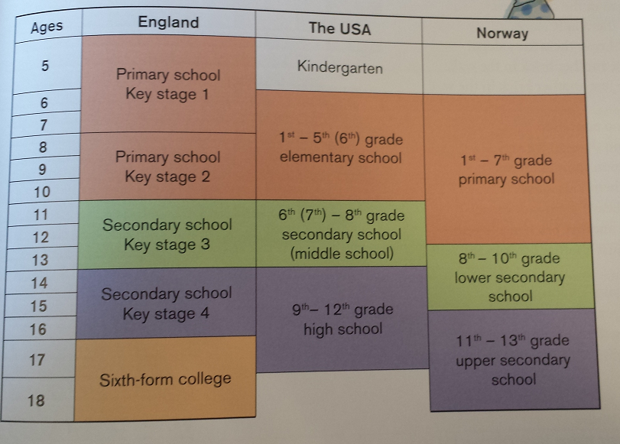

School Subjects
England | USA | Norway
English  - Language  - Litterature  Maths  World History  History  Geography  Social studies  Science  Physical Education ( Phys. Ed, PE)  Food technology  Art and Design  Religious Education (R.E)  Music  IT | Home Economics in USA | English  Mattematics  Social studies  Nature studies  Musics

